
 | Under sensitive observations  ‘A lot feels like a little’ | Over sensitive observations  ‘A little feels like a lot’ | Possible strategies
 | e.g., Sam gets out of his chair to touch the whiteboard when the teacher is reading. |  | e.g., While the teacher is reading, Sam is given a small whiteboard to draw on while he listens to the teacher.


Tactile (Touch)


Visual (Sight)


Gustatory
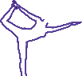
(Oral Sensations)
Vestibular (Movement)


Auditory (Sound)


Olfactory (Smell)
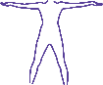

Proprioception
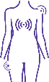

Interoception

