What is the observable behaviour you want to know more about?
Complete the table by clicking on and then typing into the grey boxes. Put as much detail as possible into the table by working together; school, parents/carers & where appropriate the student.
People involved in completing the tool:

 | People | Place | Activity | Time | Think about:
Behaviour is MOST likely to occur when: | Who is usually around when the behaviour occurs? You can write as many names as is relevant: | Where does the behaviour usually occur? You can write one or more places: | Think about activities that the person is engaged in when the behaviour typically occurs. You can write one or more activities: | Is there a time of day, day of week, etc. when the behaviour is most likely to occur? | This column is optional. Is the young person making choices about their behaviour or are they being driven by their brain or biology?  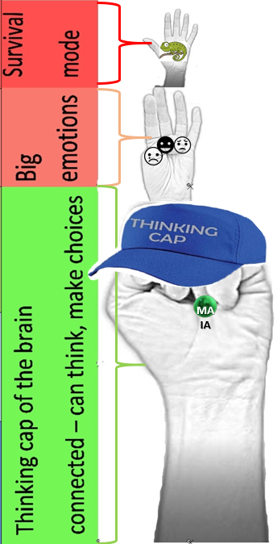
Behaviour is LEAST likely to occur when: | Who is around when the behaviour rarely or never occurs? You can write as many names as is relevant: | In what places does the behaviour rarely or never occur? You can write one or more places: | What activities rarely or never result in this behaviour? | Is there a time when the behaviour is not likely to occur? Write down times other than when the individual is sleeping. | This column is optional. Is the young person making choices about their behaviour or are they being driven by their brain or biology?

