 | Under responsive observations  ‘A lot feels like a little’ | Over responsive observations  ‘A little feels like a lot’ | Possible strategies
 | e.g., Sam gets out of his chair to touch the whiteboard when the teacher is reading. |  | e.g., While the teacher is reading, Sam is given a small whiteboard to draw on while he listens to the teacher.

Tactile (Touch)

Visual (Sight)

Gustatory
(Oral Sensations)

Vestibular (Movement)

Auditory (Sound)

Olfactory (Smell)
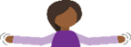

Proprioception
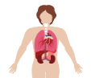

Interoception

